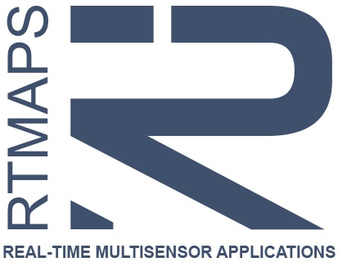 | How to install the RTMaps SDK Wizard  for Microsoft Visual C++ Express ?

Microsoft Visual C++ Express is the light (and free) version of the well-known C++ development environment from Microsoft. It does not support “add-ins” as in standard versions of Visual Studio. So, the RTMaps SDK Wizard cannot be integrated automatically in the Microsoft Visual C++ Express menus when installing RTMaps. However we provide an external tool that you will be able to integrate by hand in your VC++ Express environment. This wizard can also be used on Microsoft Visual C++ Community and Professional editions but it is recommended to use the dedicated wizard instead.
Here are the few necessary steps.

- Start Microsoft Visual C++ Express
- Select menu Tools then External Tools…
- Click on “Add” button.
- For the new tool, the configuration is:
  - Title:
RTMaps SDK Wizard
  - Command, depending on your installed version of Visual C++ Express:
%RTMAPS_SDKDIR%\tools\rtmaps_sdk_wizard_vc2008.cmd
%RTMAPS_SDKDIR%\tools\rtmaps_sdk_wizard_vc2010.cmd
%RTMAPS_SDKDIR%\tools\rtmaps_sdk_wizard_vc2012.cmd
%RTMAPS_SDKDIR%\tools\rtmaps_sdk_wizard_vc2013.cmd
%RTMAPS_SDKDIR%\tools\rtmaps_sdk_wizard_vc2015.cmd
%RTMAPS_SDKDIR%\tools\rtmaps_sdk_wizard_vc2017.cmd
  - Arguments:
$(SolutionDir)\$(SolutionFileName)
  - Initial Directory:
    - For RTMaps 4.5.0 or older: $(SolutionDir)
    - For more recent releases you can leave it blank
  - Check the “Use Output Window” option.

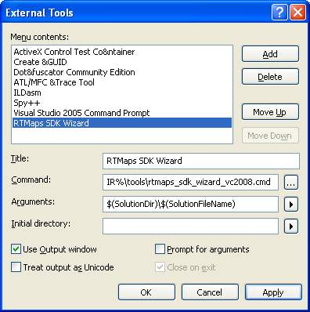
Figure 1 - Setup of the RTMaps SDK Wizard for VC++ 2008 Express

That’s it; you can now access the wizard from the Tools menu. You can also move the shortcut to a toolbar through the menu Tools | Customize menu.

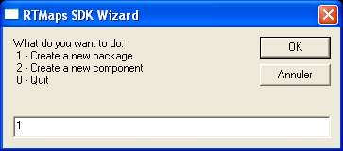
Figure 2 - The RTMaps SDK Wizard for VC++ Express

Note
Each time you create a new project or component in the RTMaps SDK with that wizard, the Visual C++ Solution file and/or Project files will be modified by the wizard. So Visual C++ will detect that modification and suggest to Reload it. Just accept by clicking on the “Reload” button.

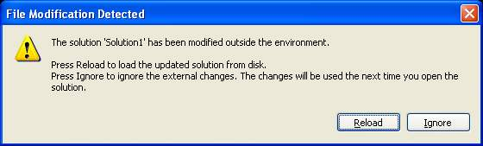
Figure 3 - Visual Studio detects the Solution file or a Project file has been modified and needs to be reloaded.

